ELEC-2110

Electric Circuit Analysis

FROM: Jacob Howard

TO: Markus Kreitzer

DATE: September 30, 2019

LAB SECTION: 002

***Problem Solving: Nodal and Mesh Analysis***

# Introduction

The Objective of this lab was to work with nodal analysis, loops, and matrices. We were to solve each circuit using the matrices we found when working on the problems. Matlab was useful in solving each matrix, as it was just plugging in numbers; Matlab calculates the rest.

# Exercise 1

In exercise 1, we were asked to write nodal equations in matrix form for the circuit in Figure 1 and solve for V0. Use MATLAB to solve your equations [1]. The circuit is shown in Figure 1 and the OCTAVE code (free alternative to matlab) solution is listed below in OCTAVE code 1.

*OCTAVE Code 1*

>> a=[-1 2 -2 0;0 -2 5 -1;2 -2 -1 3;-1 0 0 1]

a =

-1 2 -2 0

0 -2 5 -1

2 -2 -1 3

-1 0 0 1

>> b=[2;24;0;6]

b =

2

24

0

6

>> a\b

ans =

0

5

8

6

*Figure 1*

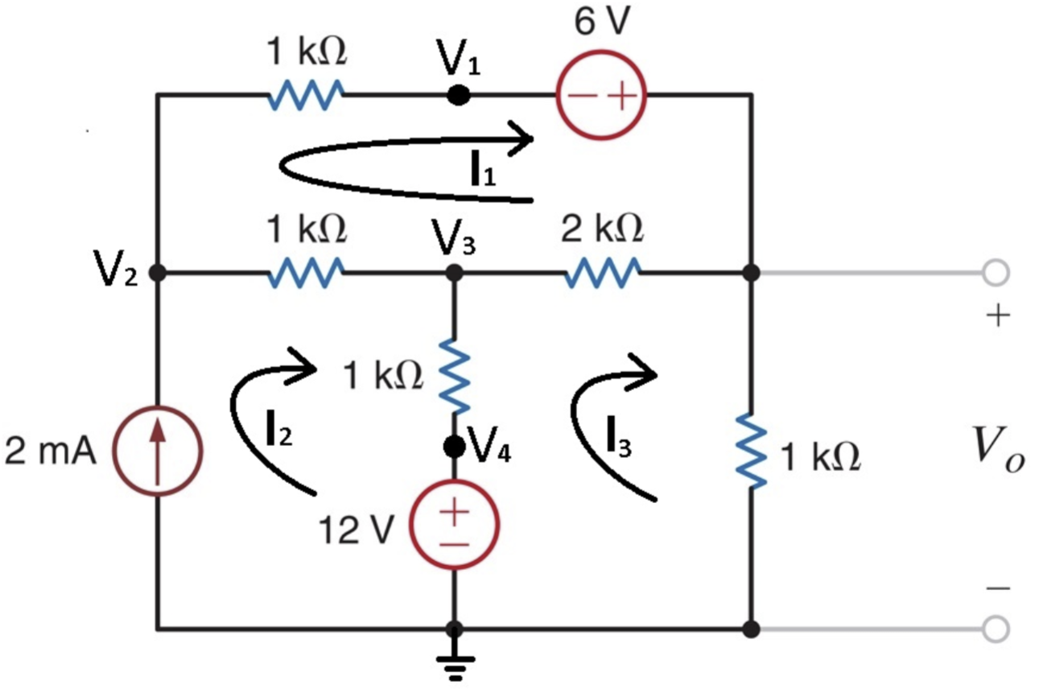

# Exercise 2

In exercise 2, we were asked to Write nodal equations in matrix form for the circuit in Figure 2 and solve for V0. Use MATLAB to solve your equations. Include code or screenshot of MATLAB script and results [1]. The OCTAVE code is below in OCTAVE Code 2.

*OCTAVE Code 2*

>> a=[1/4,0,1/6; 1,0,-1; 0,-1,1]

a =

0.25000 0.00000 0.16667

1.00000 0.00000 -1.00000

0.00000 -1.00000 1.00000

>> b=[6;12;6]

b =

6

12

6

>> a\b

ans =

19.2000

1.2000

7.2000

*Figure 2*

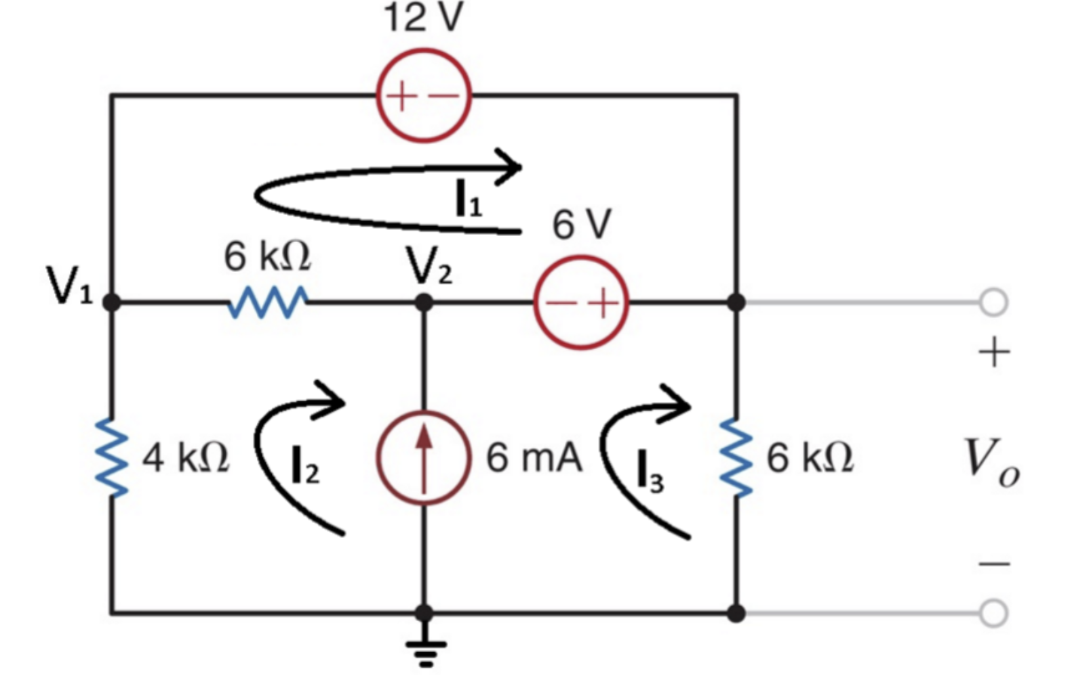

# Exercise 3

In exercise 3, we were asked to write nodal equations in matrix form for the circuit in Figure 3 and solve for V0. Use MATLAB to solve your equations. Include code or screenshot of MATLAB script and results [1]. Solution is shown below in OCTAVE Code 3.

*OCTAVE Code 3*

>> a=[2000 3000 -1000 0 0; 1 -4 0 0 0; 0 -1000 3000 -1000 -1000; 0 0 0 1 0; 0 0 -1000 0 2000]

a =

2000 3000 -1000 0 0

1 -4 0 0 0

0 -1000 3000 -1000 -1000

0 0 0 1 0

0 0 -1000 0 2000

>> b=[-6;0.004;6;-0.002;12]

b =

-6.0000000

0.0040000

6.0000000

-0.0020000

12.0000000

>> a\b

ans =

0.00022642

-0.00094340

0.00362264

-0.00200000

0.00781132

>> c=inv(a)*b

c =

0.00022642

-0.00094340

0.00362264

-0.00200000

0.00781132

>> v0=c(5)*1000

v0 = 7.8113

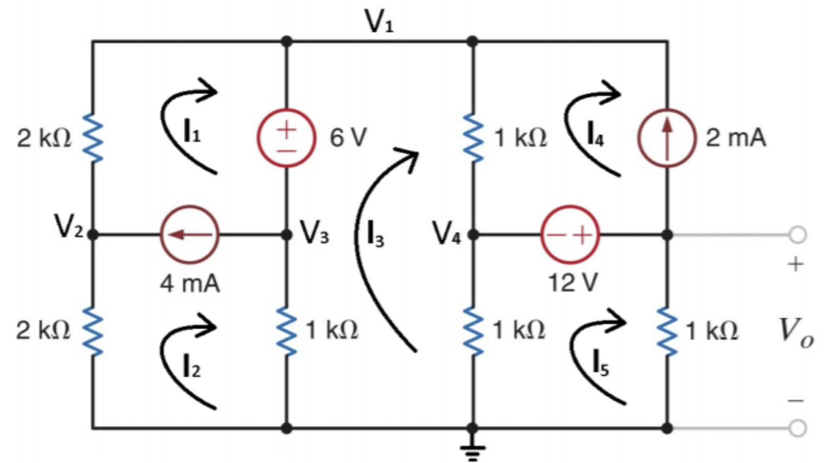

*Figure 3*

# Exercise 4

In exercise 4, we were asked to write nodal equations in matrix form for the circuit in Figure 4 and solve for V0. Use MATLAB to solve your equations. Include code or screenshot of MATLAB script and results [1]. The code solution is listed in OCTAVE Code 4 below.

*OCTAVE Code 4*

>> a=[6 -4 3; 1 -10 -1; -2 5 0]

a =

6 -4 3

1 -10 -1

-2 5 0

>> b=[288;0;-144]

b =

288

0

-144

>> c=inv(a)*b

c =

150.261

31.304

-162.783

>> v0=c(3)

v0 = -162.78

*Figure 4*

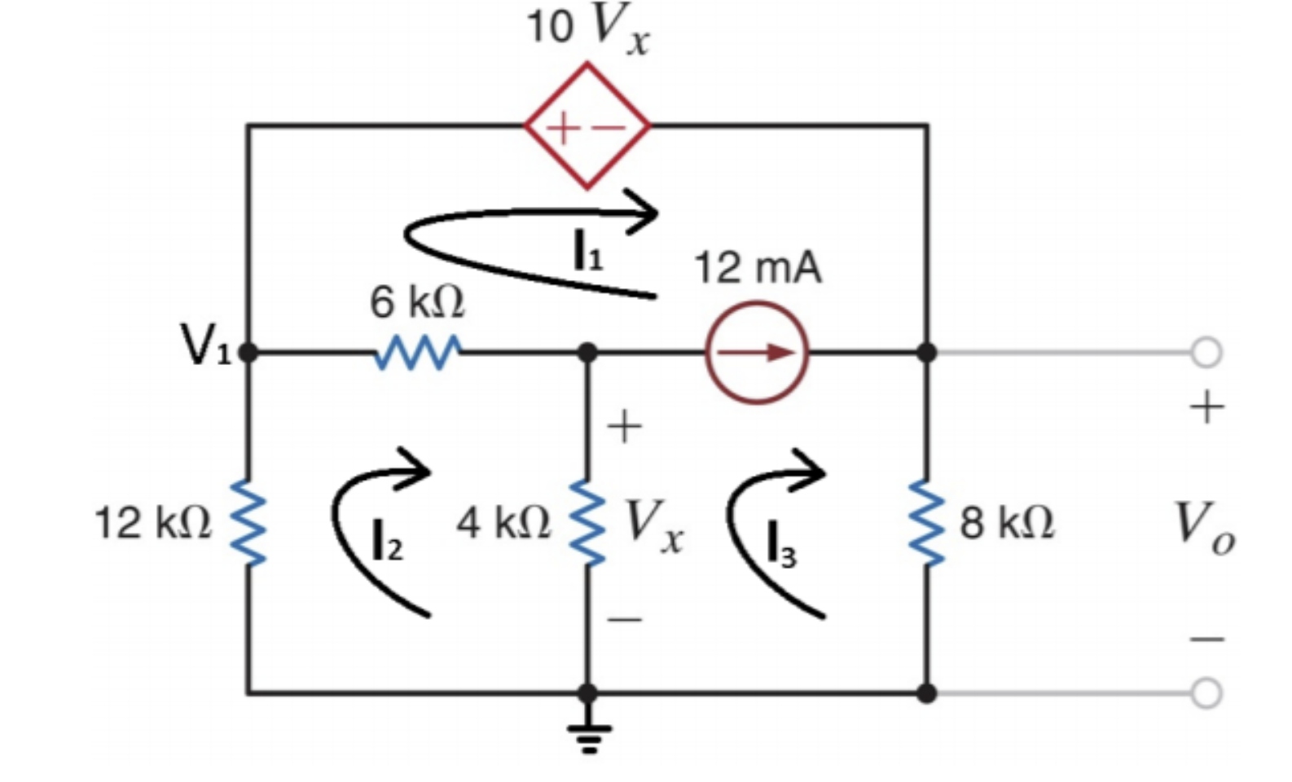

# Exercise 5

In exercise 5, we were asked to write nodal equations in matrix form for the circuit in Figure 5 and solve for I0. Use MATLAB to solve your equations [1]. The code is shown in OCTAVE Code 5 and 6 below.

*OCTAVE Code 5 (Voltage)*

>> a=[2 4 3 -2;1 0 -1 0; -1 -1 -3 3;0 2 0 -1]

a =

2 4 3 -2

1 0 -1 0

-1 -1 -3 3

0 2 0 -1

>> b=[6;12;0;-6]

b =

6

12

0

-6

>> v=inv(a)*b

v =

10.8000

-2.1600

-1.2000

1.6800

*OCTAVE Code 6 (Current)*

>> a=[2 0 0 -1 0 0;-1 0 0 2 -1 2;0 2 -1 0 -1 0;0 -1 -1 -1 2 2; 0 0 0 2 -1 -1; 0 0 1 0 0 0]

a =

2 0 0 -1 0 0

-1 0 0 2 -1 2

0 2 -1 0 -1 0

0 -1 -1 -1 2 2

0 0 0 2 -1 -1

0 0 1 0 0 0

>> b=[-12;0;12;0;0;-6]

b =

-12

0

12

0

0

-6

>> i=inv(a)*b

i =

-6.48000

3.12000

-6.00000

-0.96000

0.24000

-2.16000

*Figure 5*

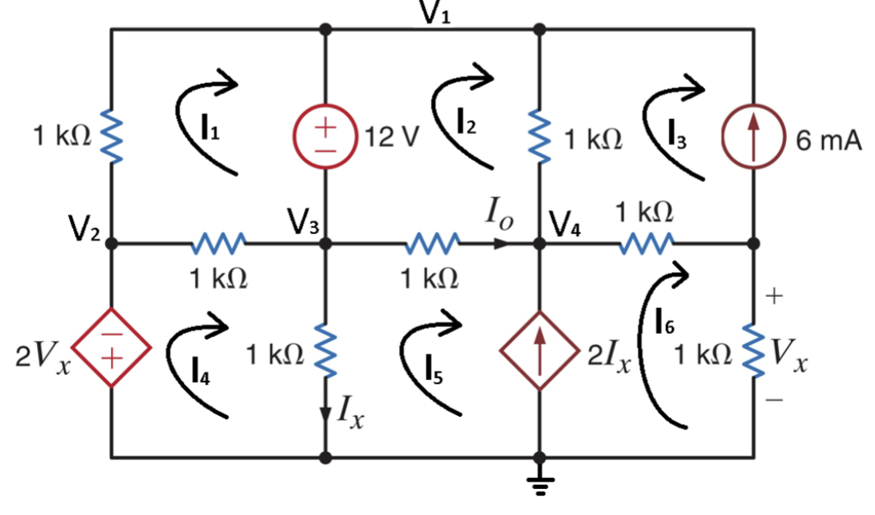

# Conclusion

This lab was used as more of a homework assignment using nodal analysis and matrices. We were to use matlab to help us solve each matrix. There were some struggles in solving each equation on paper, but once the matrix was found, it was simple enough to plug the data in to Octave.

# Bibliography

[1] Nelms, R. Mark, and Elizabeth Devore. *Problem Solving: Nodal and Mesh Analysis*. 2016, p. 5, Accessed 30 Sept 2019.